Class : II…… EVS WORKSHEET - Date : ………….
MODES OF TRANSPORT
Name : ……………………………….. Roll no………
1. Name these vehicles and put them under the correct heading.

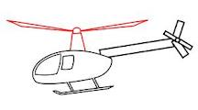
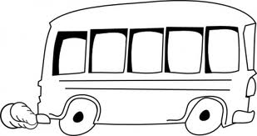
……………………………. ………………….

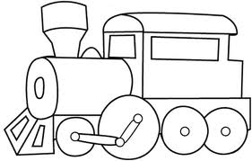
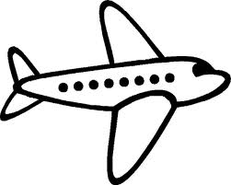
………………………… ………………………
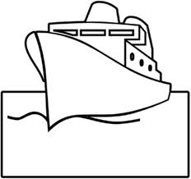
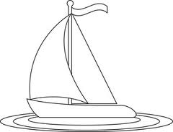

………………………….. ………………………
Land transport Water transport Air transport
1……………….. 1……………….. 1………………. 2……………….. 2……………….. 2……………….
2. Put these vehicles in the right box.
Cycle, cycle rickshaw, bus , auto rickshaw, train , container truck , tonga , scooter
Two wheeled | Three wheeled | Four wheeled | More than four wheels
3. Name these vehicles.
a. I am the ship of the desert ……………
b. People carry me on their shoulders…………………
c. I run on rail with many wheels……………………
d. I have two wheels and I am very light…………………
e. It is seen in the sea. It is very big …………………….

